*Supplementary material for*

Mapping contiguous XCO2 by machine learning and analyzing the spatio-temporal variation in China from 2003 to 2019

Mengqi Zhanga, Guijian Liua*

a: School of Earth and Space Sciences, University of Science and Technology of China, Hefei 230026, China

* Corresponding author. E-mail address: [lgj@ustc.edu.cn](mailto:lgj@ustc.edu.cn) (G. Liu)

**Content**

Figure S1. Violin plot of XCO2 difference between ACOS-GOSAT and BESD-SCIAMACHY.

Figure S2. Violin plot of XCO2 difference between ACOS-OCO-2 and ACOS-GOSAT.

Figure S3. The difference in XCO2 before and after the unification for SCIAMACHY.

Figure S4. The difference in XCO2 before and after the unification for GOSAT.

Figure S5. The difference in XCO2 before and after the unification for OCO-2.

Figure S6. The XCO2 mean bias and standard deviation between CT2019B and CTNRT.V2022-1 for global and East Asia.

Figure S7. The global XCO2 mean bias between CT2019B and CT-NRT.V2022-1.

Figure S8. The mechanism of channel attention and spatial attention in this study.

Figure S9. Illustration of the convergence of the machine model.

Figure S10. Spatial evaluation of the ML result.

Figure S11. The location of in-situ sites in China.

Figure S12. Spatial distribution of XCO2 for some months.

Figure S13. Time series of the zonally averaged XCO2.

Figure S14. The average seasonal cycle amplitude (SCA) of the ML result.

Figure S15. The SCA for CT-XCO2, CAMS-XCO2, and Kriging interpolation result and main climate zones in China.

Figure S16. A comparison of CO2 growth rates and the relationship between CO2 growth rate and ENSO index.

Figure S17. Spatial distribution of CO2 growth rates in China from 2003 to 2019.

Table S1. In-situ site information.

Text S1. A detailed description of the training process.

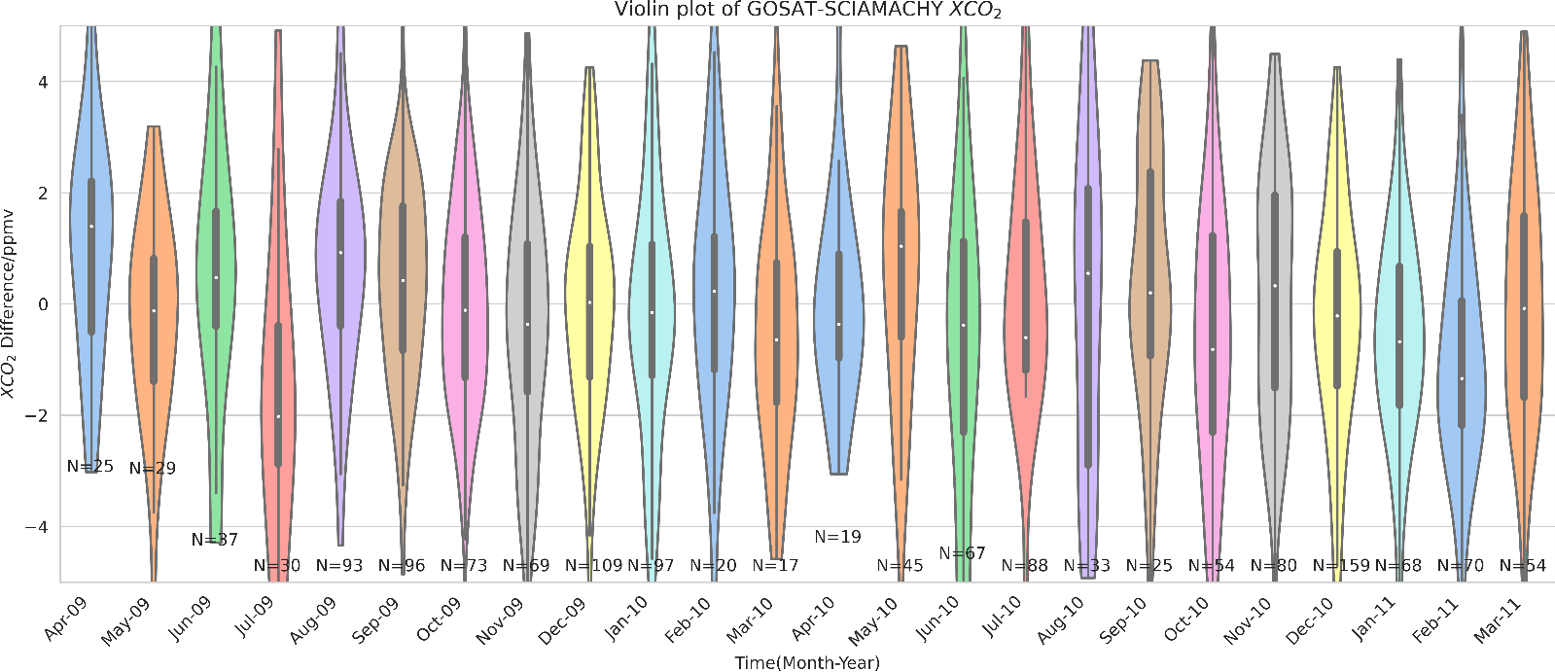

Figure S1. Violin plot of XCO2 difference between ACOS-GOSAT and BESD-SCIAMACHY. Colors are used to distinguish months. The number of valid observation points that coincide is marked on each violin's bottom.

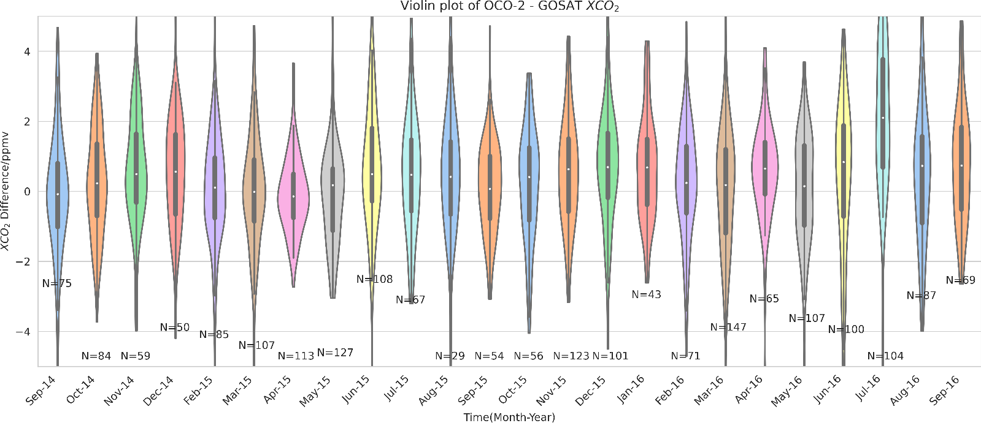

Figure S2. Same as Fig. S1 but for ACOS-OCO2 and ACOS-GOSAT.

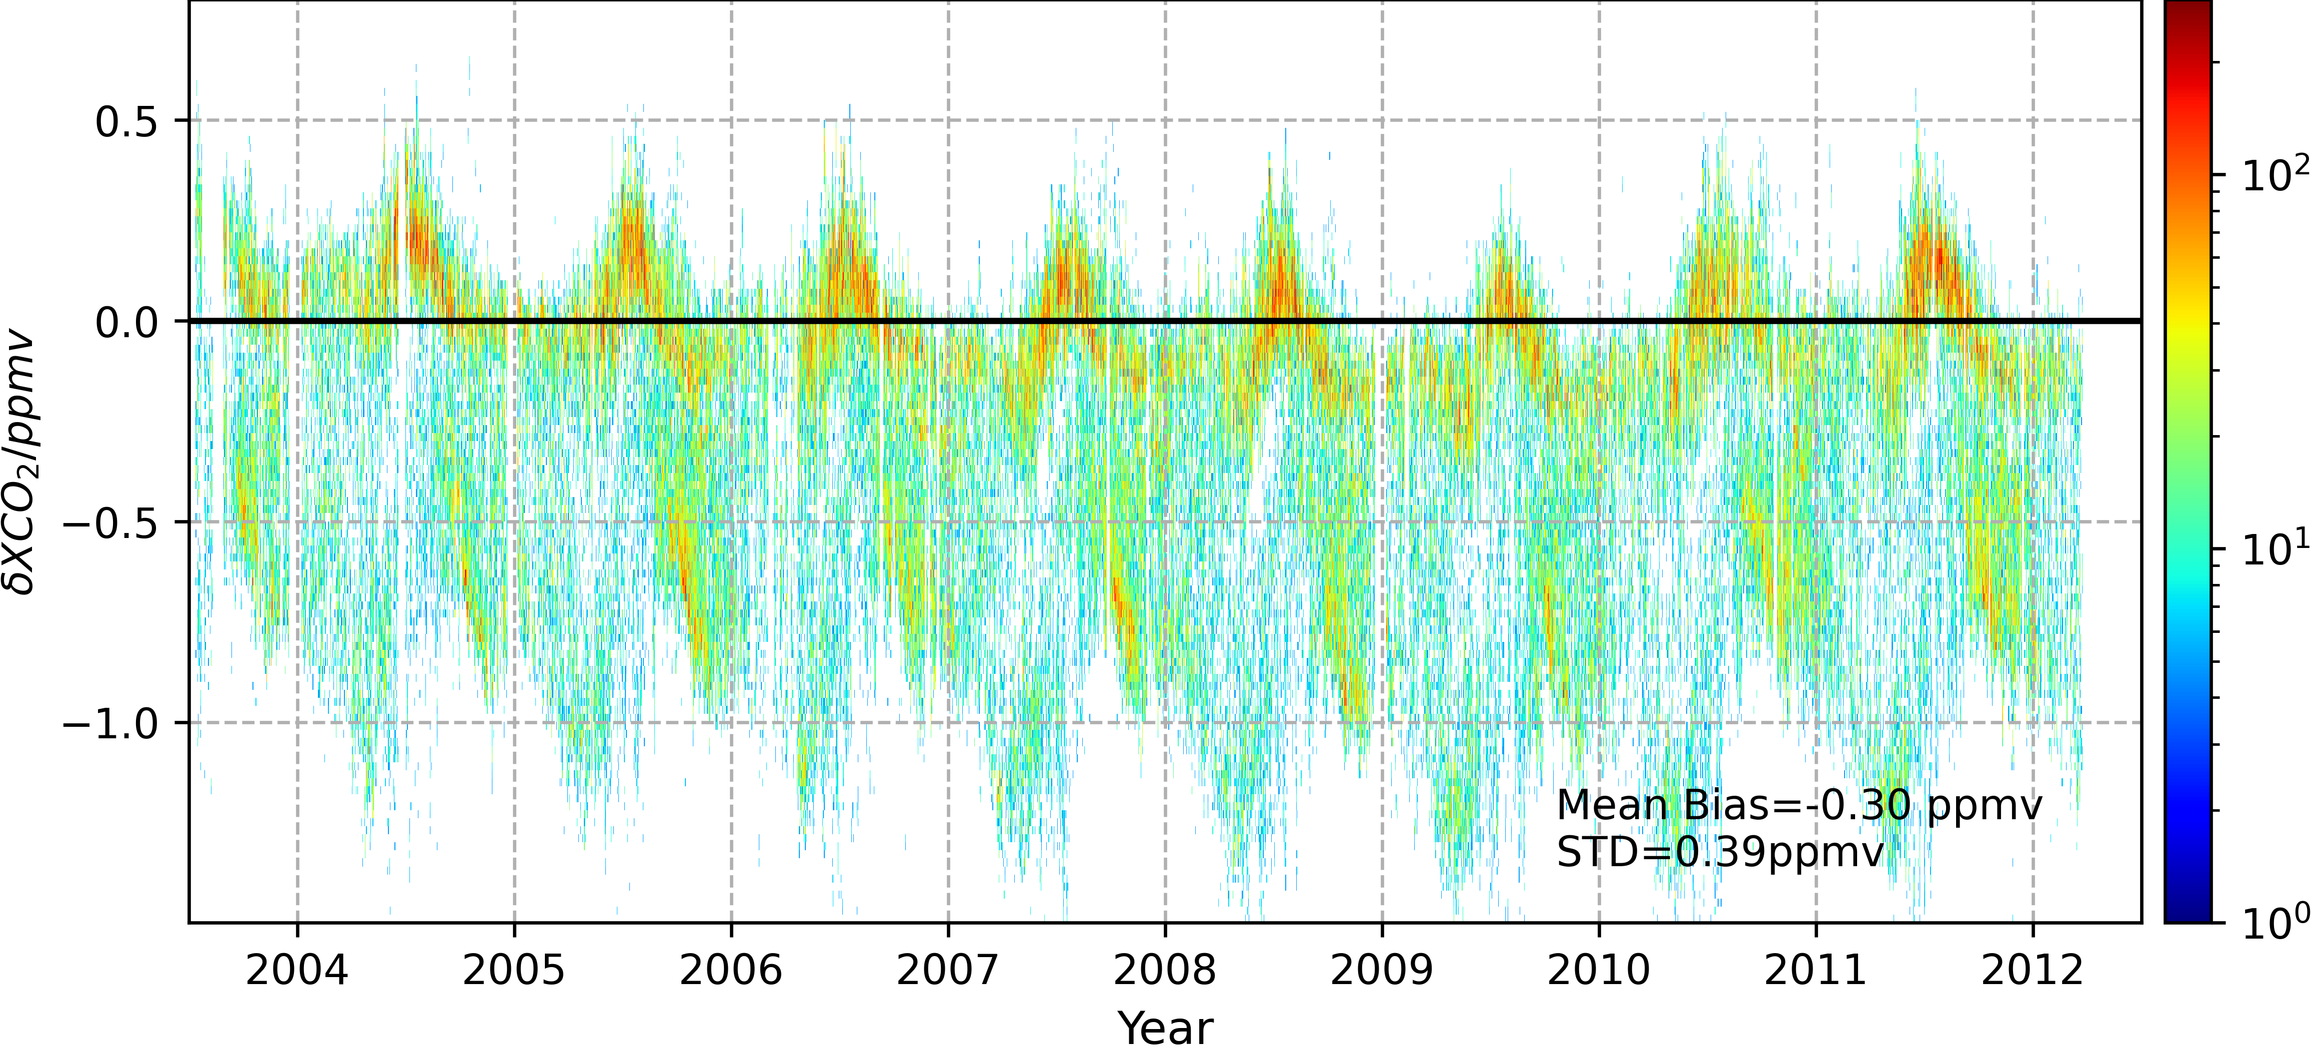Figure S3. The difference in XCO2 before and after the unification for SCIAMACHY.

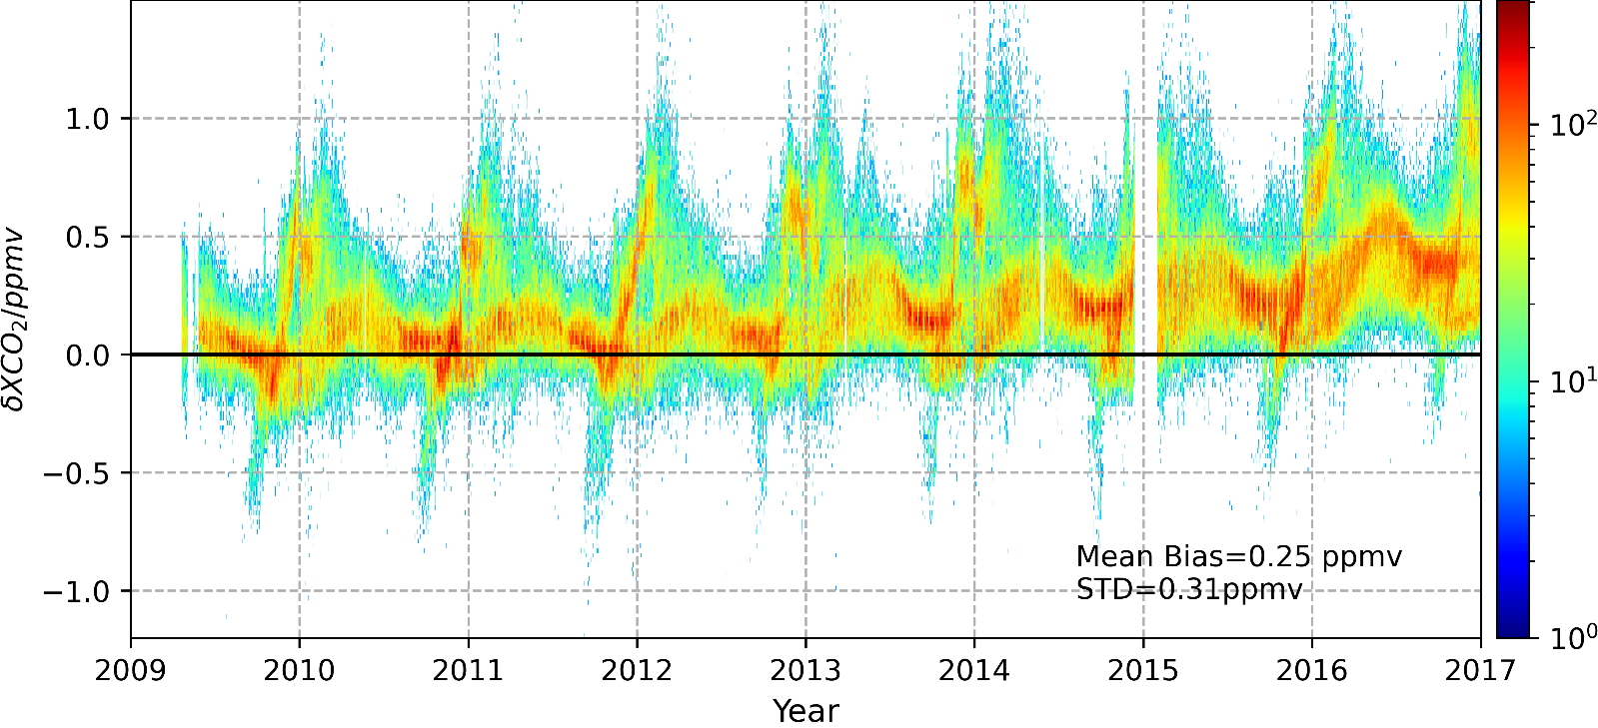Figure S4. The difference in XCO2 before and after the unification for GOSAT.

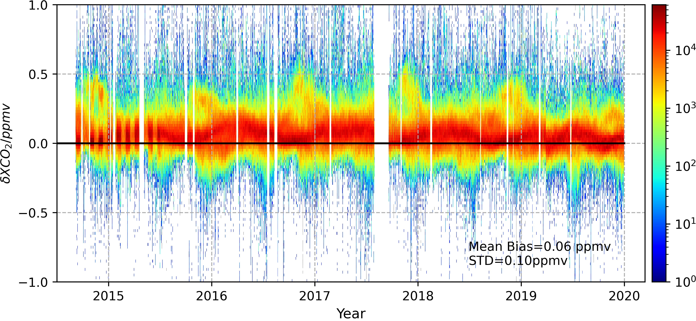

Figure S5. The difference in XCO2 before and after the unification for OCO-2.

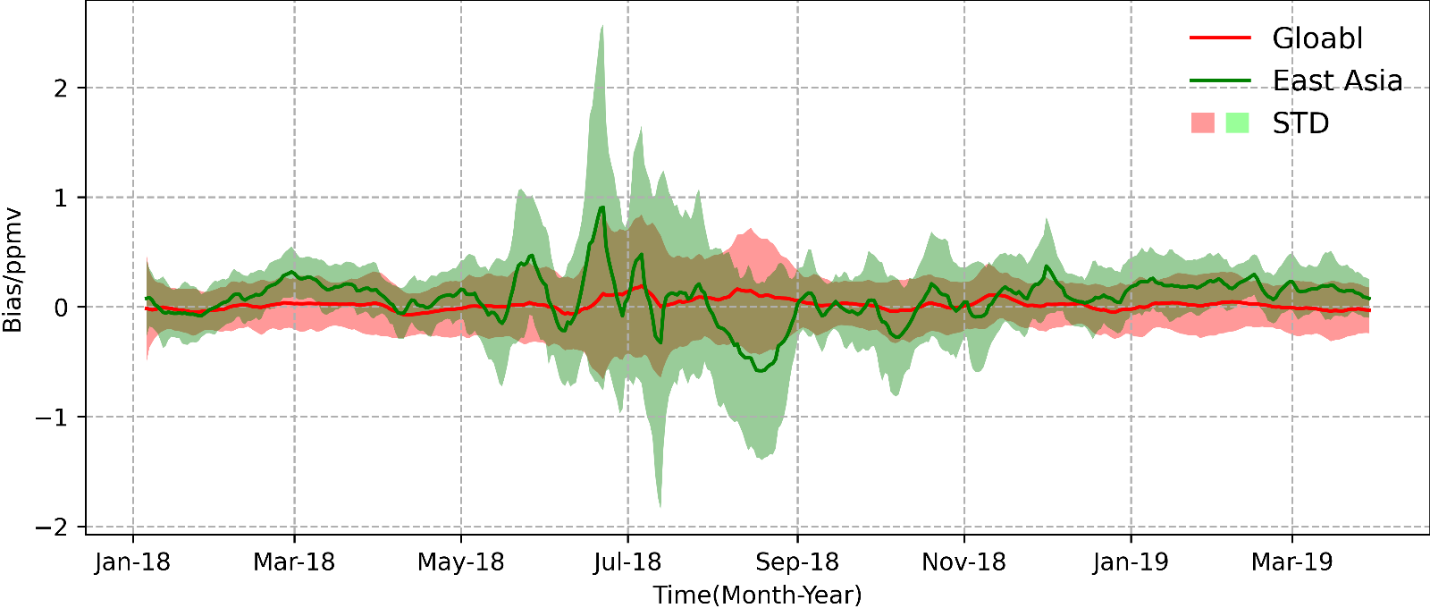

Figure S6. The XCO2 mean bias and standard deviation between CT2019B and CTNRT.V2022-1 for global and East Asia. The East Asian region is shown in Fig. S7 (b).

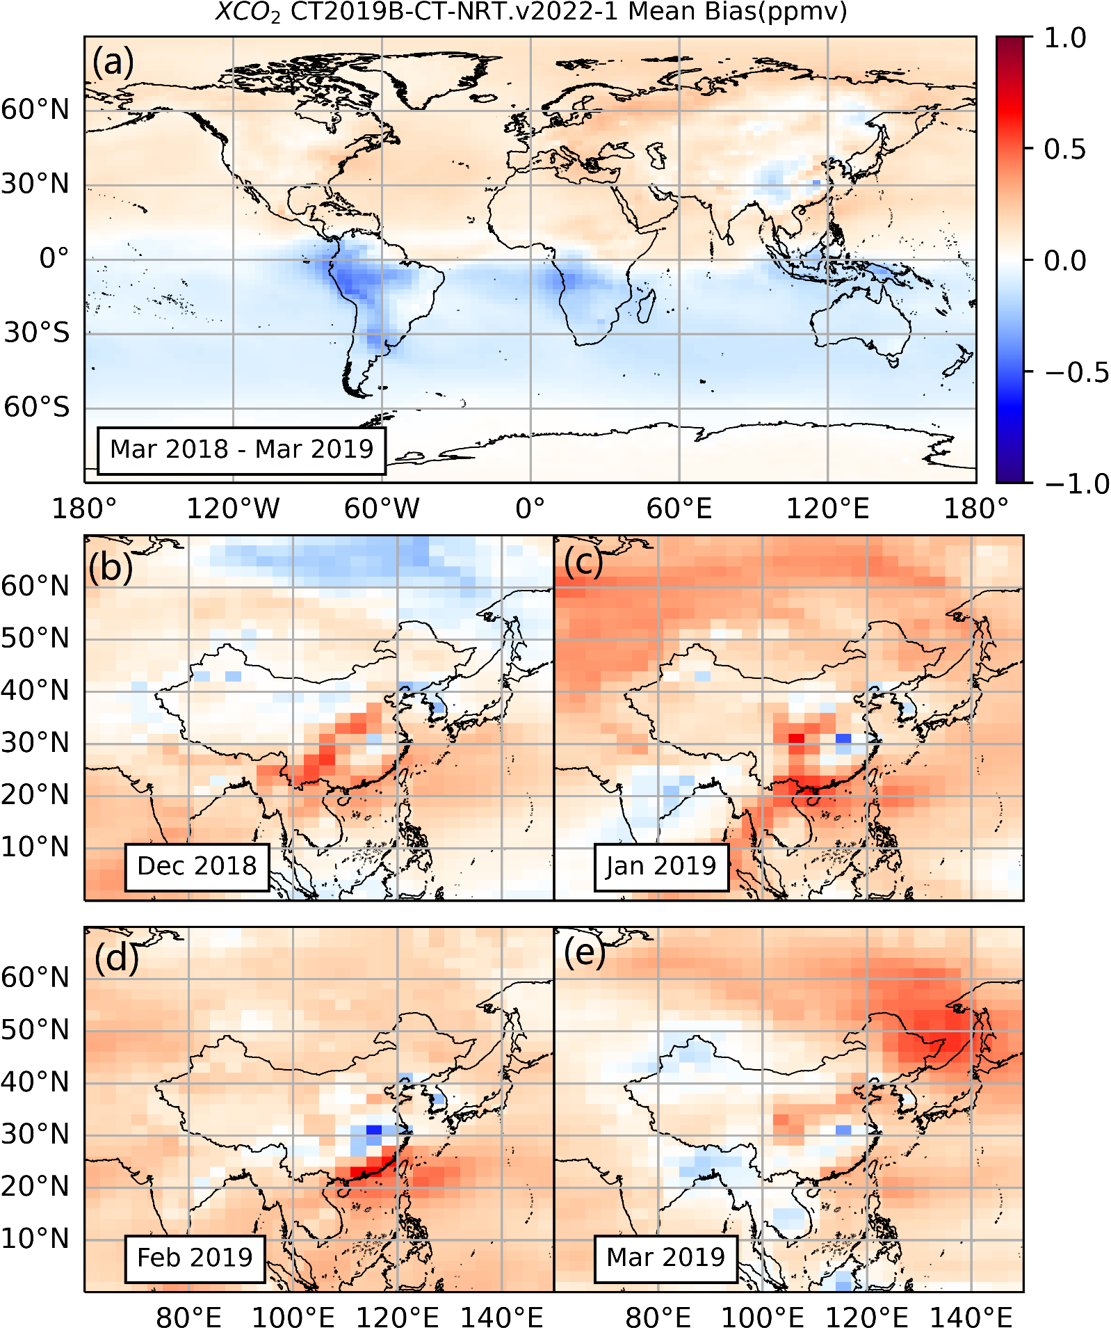

Figure S7. (a) The global XCO2 mean bias between CT2019B and CT-NRT.V2022-1 from March 2018 to March 2019. (b~e). Same as (a) but for East Asia in December 2018, January 2019, February 2019, and March 2019, respectively.

Text S1. The data probability density distribution of the variables is shown in the diagonal panel in Fig. 3. In machine learning, we expect the input and output data to be a normal distribution. However, it is challenging to meet this need in practice. It is often not practical to adjust the data distribution through the transformation function because it causes the problem of data leakage. Batch normalization often handles this problem (Ioffe and Szegedy, 2015). For this reason, we added a Batch Normalization Layer before the Fully Connected Layer.

Moreover, the target value XCO2 is relatively close to a normal distribution. But for emissions, it is a long-tailed distribution, which may be difficult for a machine model to capture, so we perform a logarithmic transformation. The problem of regression on imbalanced datasets is still a frontier issue for machine learning methods and has sparked a research boom (Krawczyk, 2016; Yang et al., 2021). Furthermore, we normalized the data by subtracting the mean and dividing it by the standard deviation. In the learning process, for each epoch, we feed data with a 500 batch size, and we use a dynamic learning rate with a ten-fold reduction when the loss is stuck (as shown in Fig. S9). When the loss of the training set and validation set no longer decreases, it means that the model has converged. However, it does not mean that it is reasonable and depends on further evaluation.

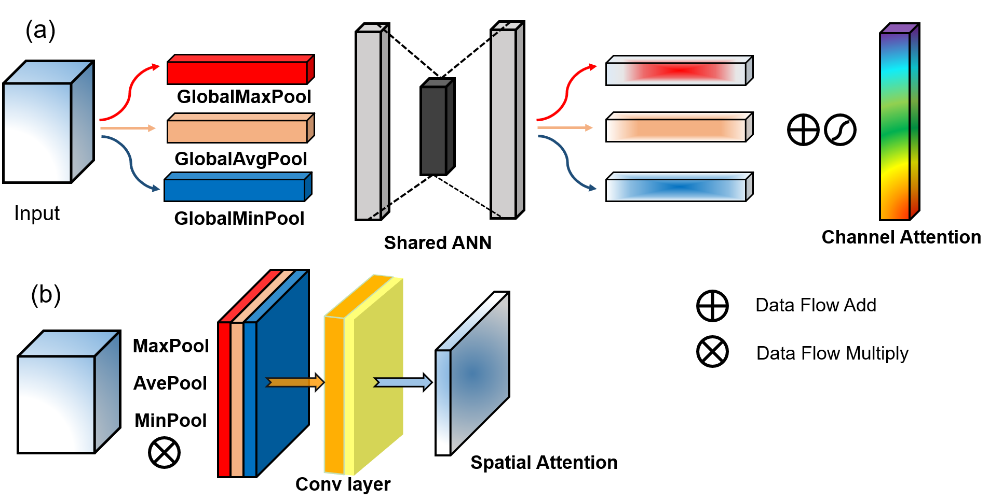

Figure S8. The mechanism of channel attention and spatial attention in this study.

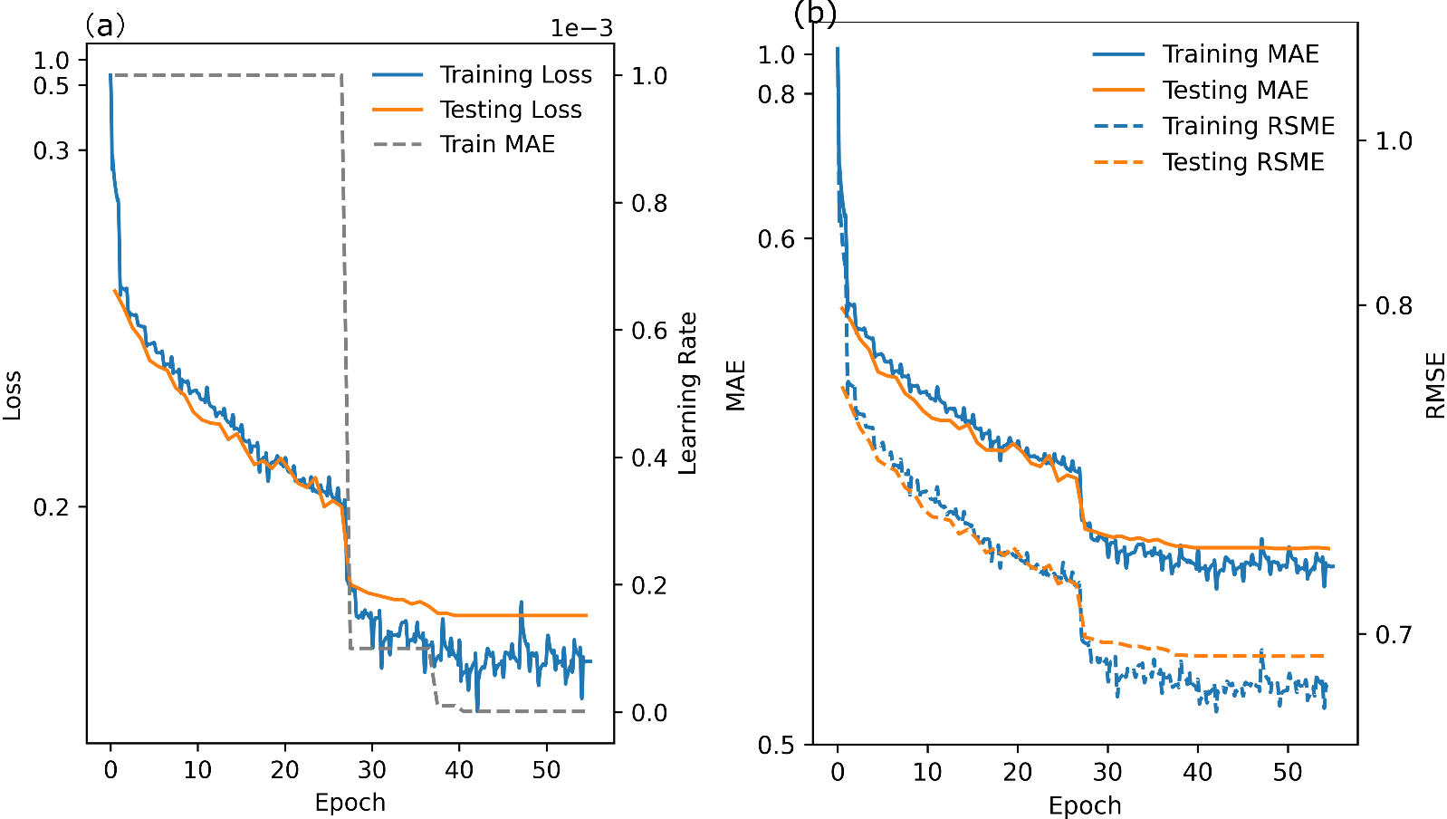

Figure S9. Illustration of the convergence of the machine model. (a) The log-cosh loss and learning rate of the training set and testing set during model training. (b) The MAE and RSME of the training set and testing set. Note that the y-axis scale is not linear to enhance the decrease of loss.

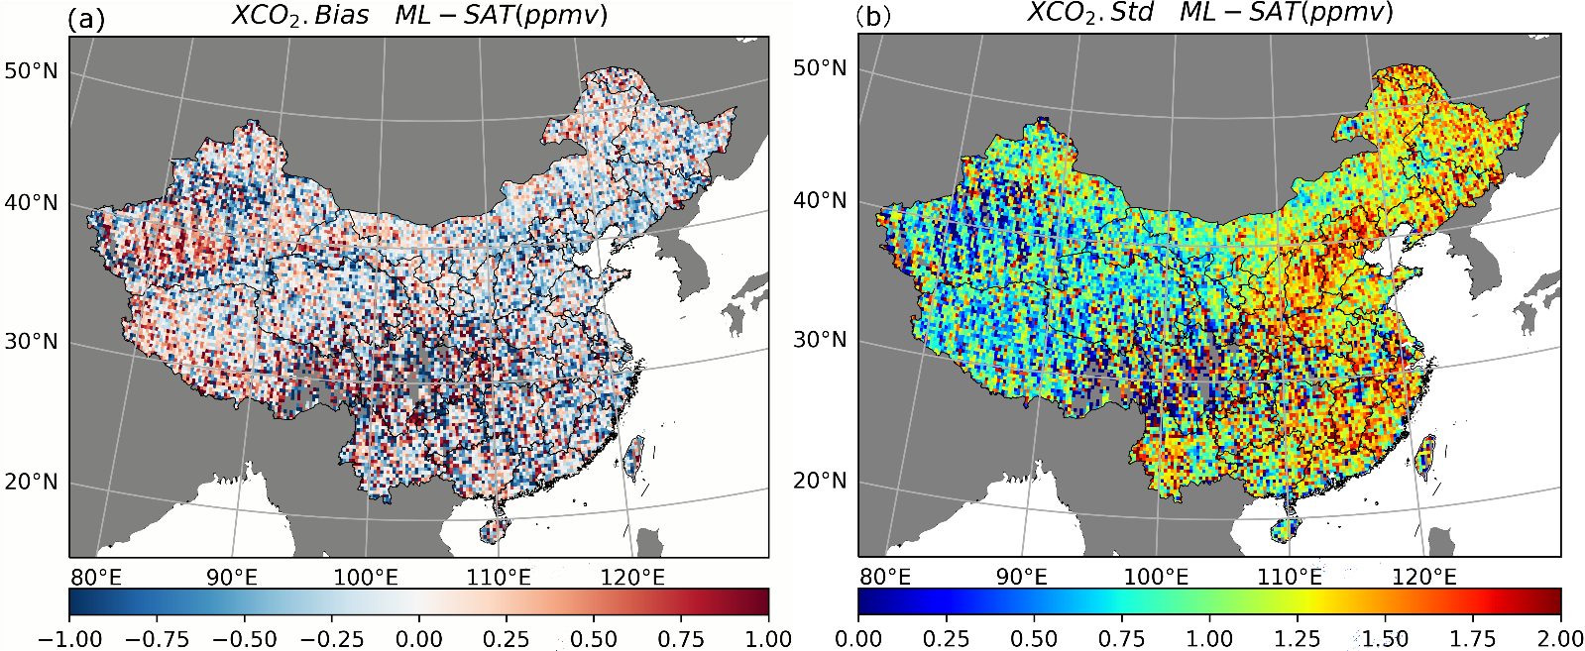

Figure S10. (a) the spatial bias between ML result and satellite data. (b). same as (a) but for standard deviation.

Table S1. In-situ site information

|  |  |  |  |  |
| --- | --- | --- | --- | --- |
| Sites | Lat/Lon/Altitude | Measuring modes | Collector | Data period |
| Akedala | 47.12°N, 87.97°E, 562 ma.s.l | flask | CMA | 2009-2016 |
| Lin’an | 30.3°N, 119.72°E, 138.6 ma.s.l | continuous | CMA | 2009-2016 |
| Jinsha | 29.63°N, 114.20°E, 750 ma.s.l | flask | CMA | 2009-2016 |
| LongfengShan | 44.73°N, 127.6°E, 331 ma.s.l | continuous | CMA | 2009-2016 |
| Shangdianzi | 40.65° N, 117.1° E, 291.3 ma.s.l | continuous | CMA | 2009-2016 |
| Shangri-La | 28.01°N, 99.73°E, 3580 ma.s.l | flask &continuous | CMA | 2009-2016 |
| Waliguan | 36.28°N, 100.90°E, 3816 ma.s.l | flask | CMA | 2009-2016 |
| Hefei | 31.91°N, 117.17°E, 30 ma.s.l. | XCO2 | TCCON | 2015-2018 |

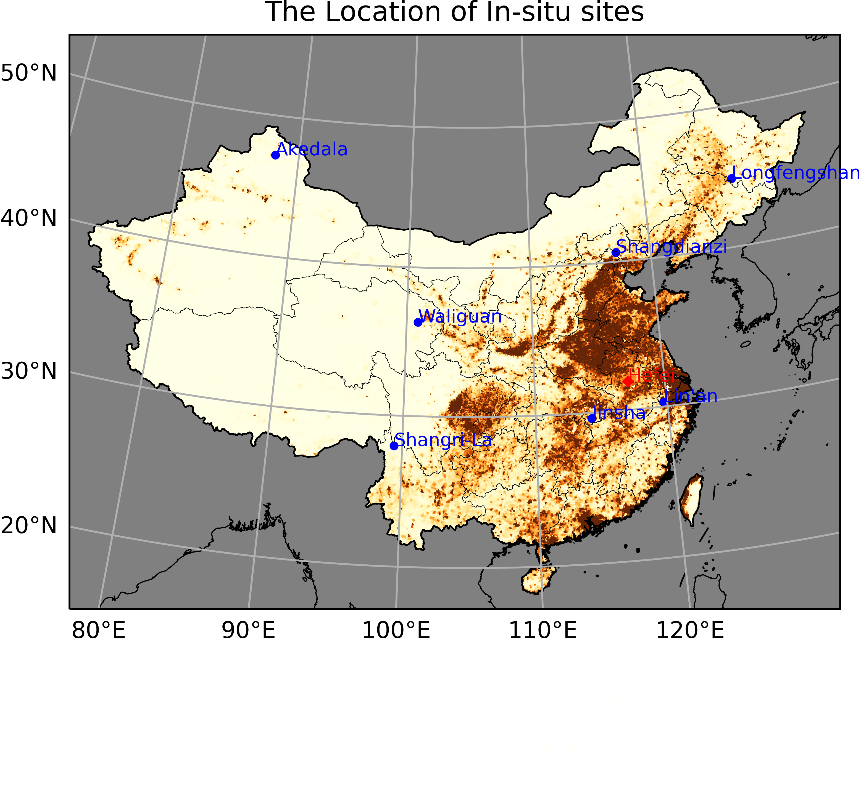

Figure S11. The location of in-situ sites in China. The red one shows the location of the TCCON-Hefei site. And the background map shows the population distribution in China.



Figure S12. Spatial distribution of XCO2 for some months. (a, d, g) the ML result for February 2006, August 2012, and November 2018. (b, e, h) same as (a, d, g) but for the CarbonTracker model. (c, f, i) same as (a, d, g) but for Kriging interpolation.

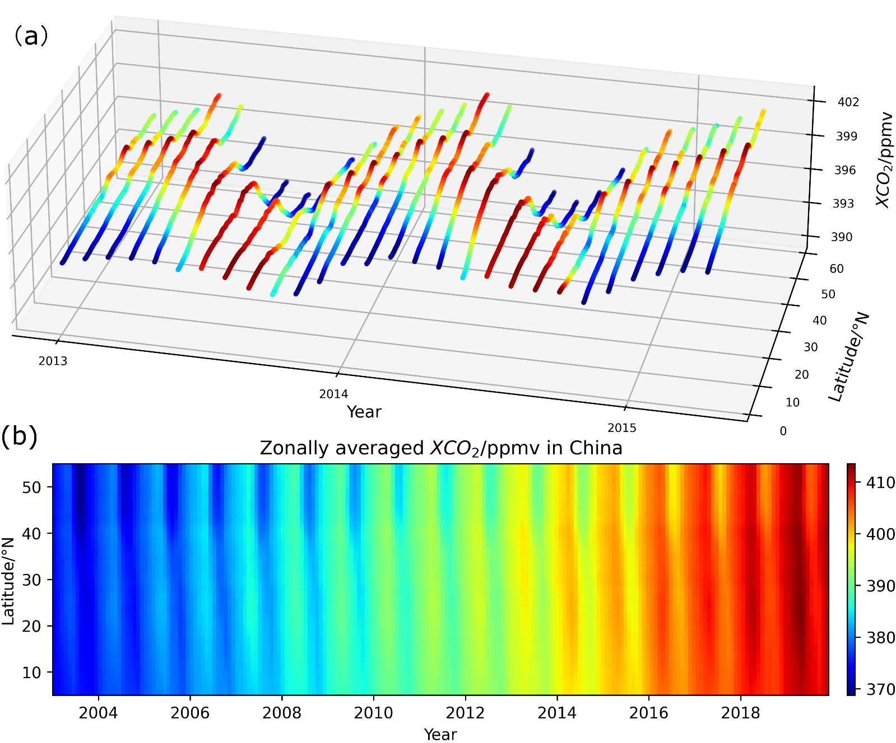

Figure S13. Time series of the zonally averaged XCO2. (a) from Jan. 2013 to Feb. 2015. Note that the color maps are for each month slice to enhance the north-south fluctuations of the CO2 peak band. (b) from Jan.2003 to Dec. 2019.



Figure S14. The average seasonal cycle amplitude of the ML result from 2003 to 2019 in China. The Qinling-Huaihe line is marked with a red dotted line in the figure.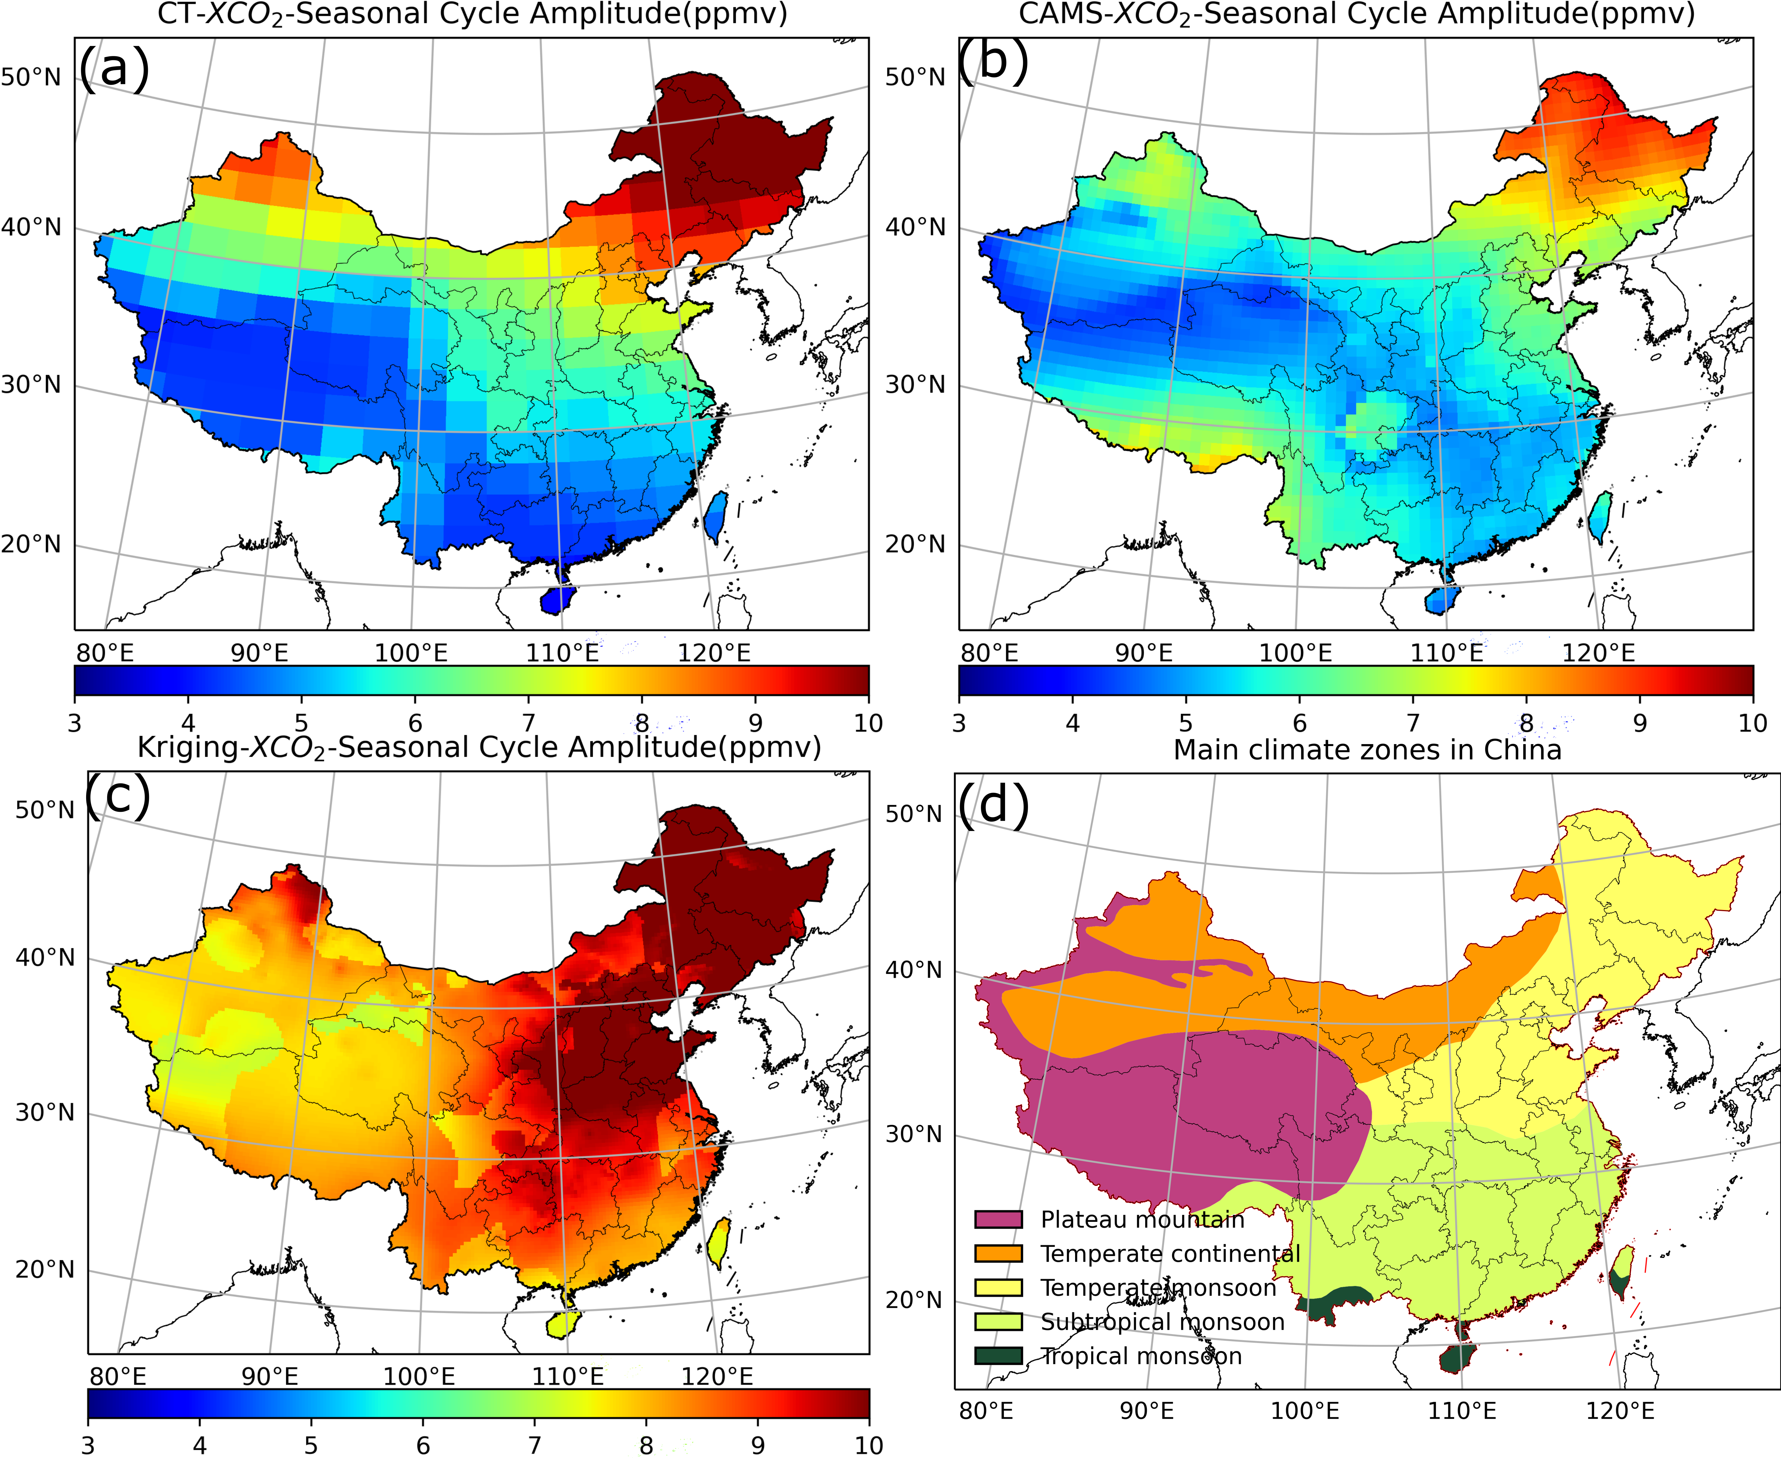

Figure S15. (a~c) same as Fig. S14 but for CT-XCO2, CAMS-XCO2, and Kriging interpolation results, respectively. (d) main climate zones in China.

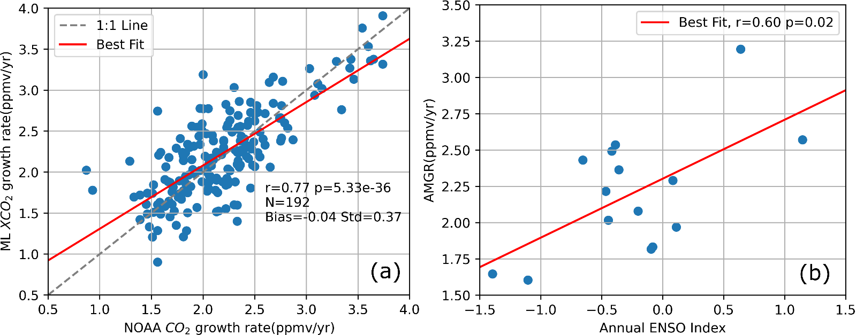

Figure S16. (a) The comparison between the CO2 growth rate of NOAA and the XCO2 growth rate of the ML result. (b) The relationship between AMGR of the ML result and annual ENSO index.

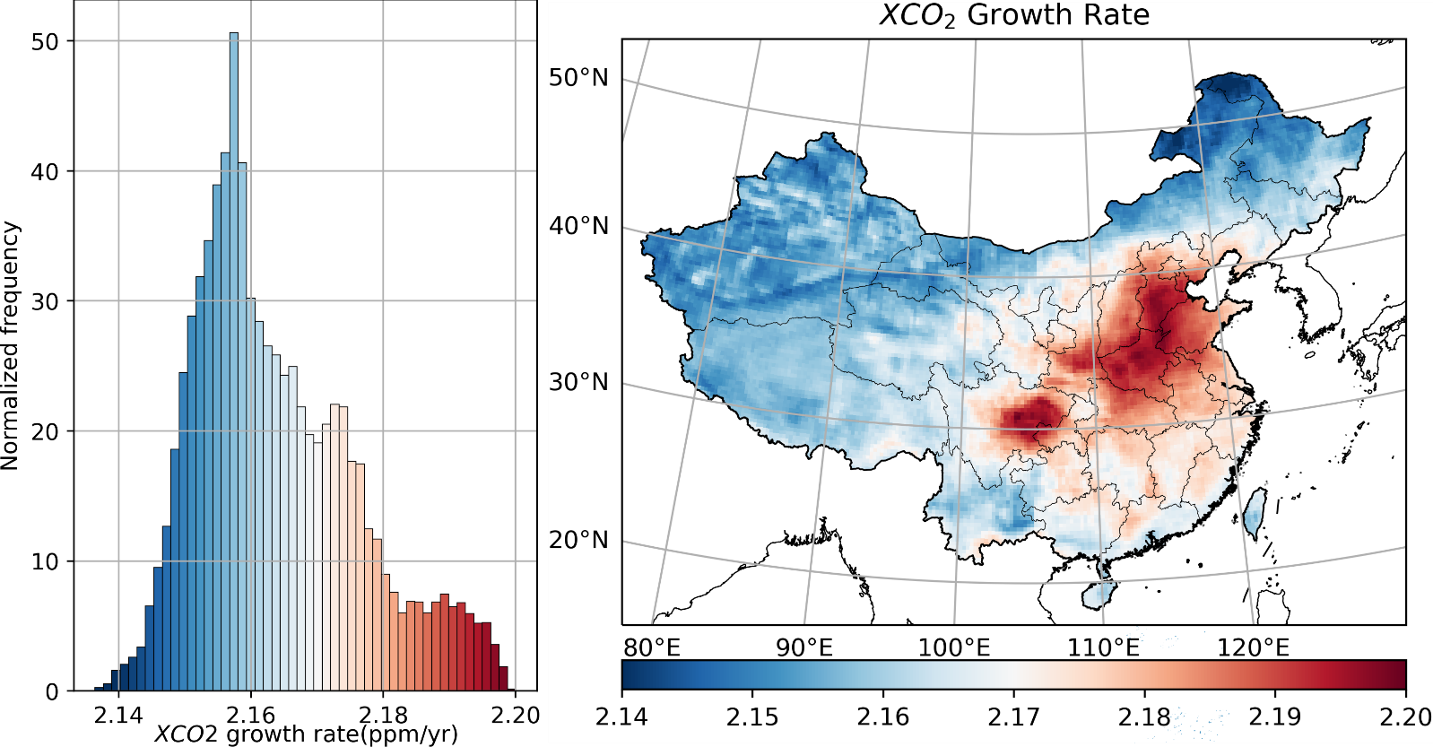

Figure S17. (a) The histogram of China XCO2 average increasing rate of this ML result during 2003-2019, and (b) is the spatial difference. This rate is calculated by the Theil-Sen estimator.

**References**

Ioffe S, Szegedy C. Batch Normalization: Accelerating Deep Network Training by Reducing Internal Covariate Shift. International Conference on Machine Learning, Vol 37 2015; 37: 448-456.

Krawczyk B. Learning from imbalanced data: open challenges and future directions. Progress in Artificial Intelligence 2016; 5: 221-232.

Yang YZ, Zha KW, Chen YC, Wang H, Katabi D. Delving into Deep Imbalanced Regression. International Conference on Machine Learning, Vol 139 2021; 139.